AI ENGINEERING COPILOT
A Lightweight, Zero-Cost, Production-Style
AI Observability & Root-Cause Diagnosis Platform
Project Design Document
Personal Engineering Project · V1 Architecture & 30-Day Build Plan
Prepared with Claude · June 2026

Table of Contents

1. Project Overview
AI Engineering Copilot is an internal-style engineering platform that watches an AI application’s executions, automatically diagnoses why a bad answer happened, backs every diagnosis with evidence, remembers past incidents, and lets an engineer safely test a fix before trusting it in production.
This is not an observability dashboard in the traditional sense. Tools like LangSmith, LangFuse, and Arize Phoenix answer “what happened” — they visualize traces, spans, and metrics. This platform is built to answer the harder question those tools mostly leave to humans: “why did it fail, and what fixes it.”

1.1 Why This Project
Modern AI systems — RAG pipelines, multi-agent systems, tool-calling agents — fail in ways that are expensive to debug manually. A single incorrect answer can require an engineer to manually inspect retrieval scores, prompts, context, LLM configuration, and tool calls, often taking minutes to hours. At production scale (thousands or millions of conversations), manual debugging becomes impossible.
The goal of this project is to build a small but architecturally honest version of the kind of platform that would solve this problem — sized for one person, zero infrastructure budget, and a 30-day build window — while preserving the real engineering patterns a production system would actually use.

1.2 What Makes This Different From a Typical Personal Project
Most personal AI projects are chatbots wrapped in a UI. This project is deliberately infrastructure-shaped: it has a real ingestion pipeline, a real background worker, a real database schema designed for growth, and a real (if scaled-down) separation between deterministic processing and AI judgment. The intent is to come out the other side understanding how a production AI infrastructure system is actually built — not to produce another resume chatbot.

2. Problem Statement
Consider a customer support chatbot answering the question: “Can I return Product X? It is within the 30-day return period.” The chatbot replies “Yes.” The actual company policy places Product X in a non-returnable category — the answer is wrong.
To find out why, an engineer must manually inspect:
- Retrieval results, embeddings, and similarity scores
- Retrieved chunks and their metadata filters
- The constructed prompt and system prompt
- LLM configuration and the generated output
- Memory access, tool calls, and agent routing decisions
- Latency, cost, and any errors or warnings along the way
Eventually, the engineer discovers the correct refund policy document was never retrieved. This single investigation might take several minutes. Now multiply that by 10,000 or 1,000,000 production conversations — manual debugging stops being a viable strategy entirely.

2.1 Where Existing Tools Fall Short
Today’s AI observability platforms — LangSmith, LangFuse, Arize Phoenix, OpenTelemetry, Helicone, MLflow, Weights & Biases Weave — are excellent at answering “what happened.” They visualize traces, spans, metrics, latency, and token usage clearly. What they rarely do is answer why the system failed, determine root cause, recommend a specific fix, surface similar historical incidents, or predict the impact of a configuration change before you make it.
That gap — between observability and actual diagnosis — is the problem this project targets.

3. Project Vision
Build a platform that behaves like an experienced senior AI engineer reviewing a debugging report — one that can answer:
- Why did this fail? Which component is responsible?
- How confident is this diagnosis, and what evidence supports it?
- Has this happened before? What fixed it last time?
- Can we safely replay this execution with a different configuration?
- What engineering change will most likely improve this system?
The platform should never simply guess. Every diagnosis must be traceable back to concrete evidence, every recommendation must explain its own reasoning, and the system should get smarter over time as more incidents are recorded.

4. Design Principles
Five principles govern every architectural decision in this system. They come directly from the original specification and are treated as non-negotiable constraints, not aspirations.
- Reliable — every diagnosis must be backed by evidence. The system never relies solely on LLM reasoning to produce a final answer.
- Explainable — every recommendation must explain why it was generated, in terms a reviewing engineer can verify.
- Lightweight — avoid unnecessary LLM calls and unnecessary multi-agent complexity. Perform deterministic processing wherever possible.
- Extensible — adding a new retriever, LLM provider, vector database, or evidence producer should require minimal code changes.
- Vendor independent — the platform should not be hard-wired to one LLM provider, one vector database, or one orchestration framework.

These principles directly motivate two of the most important architectural decisions in this document: the Evidence Producer pattern (Section 7) and the single-LLM-call Reasoning Engine (Section 8).

5. High-Level Architecture
The system is organized as a linear pipeline. Each stage consumes the output of the stage before it and produces a clean, structured artifact for the next stage. This single-direction flow is what makes the system explainable: at any point, you can ask “what did this stage receive, and what did it produce” and get a concrete answer.
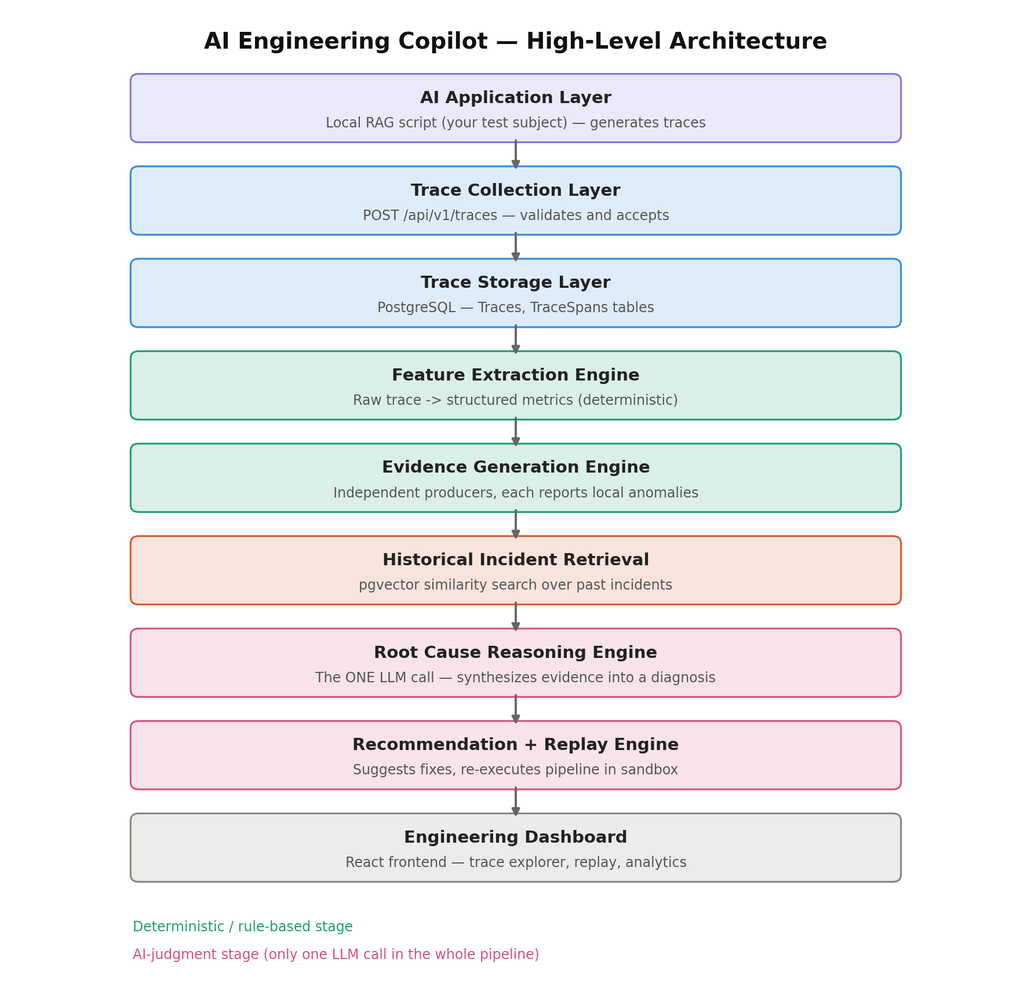
Two stages are colored differently in the diagram on purpose. The green stages (Feature Extraction, Evidence Generation) are fully deterministic — plain code, no AI involved. The pink stages (Root Cause Reasoning, Recommendation + Replay) involve AI judgment, but only the Reasoning Engine actually calls an LLM. Every other stage in the entire pipeline is ordinary, predictable code. This is the direct expression of the “Lightweight” and “Reliable” principles: the system is cheap and fast by default, and only pays the cost and unpredictability of an LLM call exactly once, after everything that can be known deterministically already has been.

5.1 The Nine Stages
Stage | What it does | Nature
AI Application Layer | The instrumented AI app generating traces (your RAG test app) | External
Trace Collection | Validates and accepts incoming execution traces via API | Deterministic
Trace Storage | Persists raw traces and spans in PostgreSQL | Deterministic
Feature Extraction | Converts raw trace JSON into clean, queryable metrics | Deterministic
Evidence Generation | Independent producers report observations per component | Deterministic (rule-based, narrow scope)
Historical Retrieval | Vector similarity search for comparable past incidents | Deterministic (similarity, not rules)
Root Cause Reasoning | The one LLM call — synthesizes evidence into a diagnosis | AI judgment
Recommendation + Replay | Suggests fixes; re-executes the pipeline in a sandbox | Mixed (replay is deterministic re-execution)
Engineering Dashboard | React frontend for humans to inspect everything above | Presentation

6. Modular Monolith, Not Microservices
The original specification describes six independent microservices (Trace, Evidence, Reasoning, Replay, Historical Learning, Analytics), each separately deployable. For a solo, zero-budget, learning-focused project, this is the wrong choice, and it is worth being explicit about why.

6.1 Why Not Microservices Here
Microservices earn their cost when different services need to scale independently, when different teams own different services, or when independent deployment matters. None of those conditions exist for a single person debugging their own test application. Running six independently deployable services multiplies operational surface area — six things to deploy, six sets of logs, six network boundaries to debug — without any of the benefits that justify that cost in a real company.

6.2 The Chosen Pattern: Modular Monolith
Instead, the backend is built as a single deployable process, internally organized into modules with hard boundaries enforced by code discipline rather than network calls. Each module owns its own folder, its own database tables, and exposes only a public interface — other modules never reach into its internals directly.
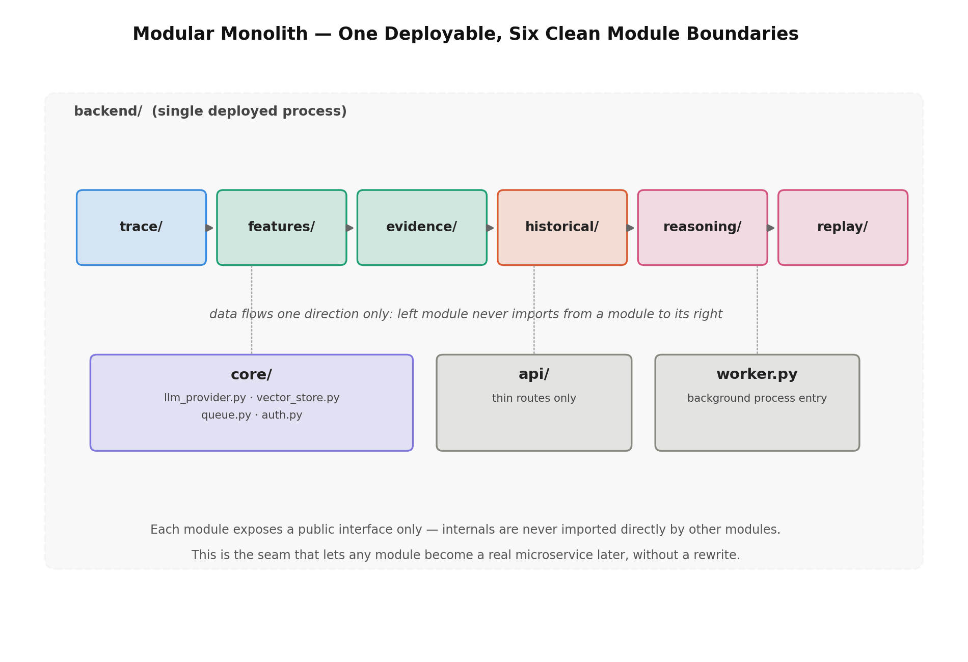
The rule that keeps this honest: data flows in one direction only. The evidence module is allowed to depend on the features module, but the features module must never import anything from evidence. If you ever find yourself importing “backwards,” that is the signal a boundary is leaking.

6.3 Why This Is the Correct Production Pattern, Not a Shortcut
This is not a simplification made only because of budget constraints — it mirrors how many real engineering organizations actually start systems like this (Shopify and early Stripe are commonly cited examples of long-lived modular monoliths). Teams split a module into a true microservice only when that specific module’s scaling needs or team-ownership needs diverge enough to justify the operational cost. Because the module boundaries here are already clean, any module — for example, Reasoning, if LLM load grew significantly — could be extracted into its own service later without a rewrite.

7. System Modules — Detailed Design

7.1 Trace Collection & Storage
Every execution of the AI application — the user query, retrieved chunks and similarity scores, the assembled prompt, LLM configuration, the generated answer, latency, cost, tool calls, and any errors — is packaged into a single structured trace and sent to the platform via a POST request.
Ingestion is deliberately kept fast and simple: validate the payload, write it to PostgreSQL, enqueue a background job, and return immediately. Nothing slow or unreliable (LLM calls, vector search) ever happens inside the ingestion request itself. This separation — fast synchronous ingestion, slow asynchronous processing — is one of the most important patterns in the entire system, and is explained fully in Section 9.

7.2 Feature Extraction Engine
Raw traces are messy: nested JSON, free text, scores buried inside retrieval result objects. The Feature Extraction Engine’s only job is translation — turning that mess into a flat, queryable set of numbers: average / max / min similarity score, prompt length, context tokens, completion tokens, latency, and cost.
This stage performs no judgment whatsoever. It is pure arithmetic over the trace’s structure. Every later stage depends on this translation having already happened — evidence producers compare numbers, not raw text; the reasoning engine receives metrics, not blobs of JSON.

7.3 Evidence Generation Engine
This is the most important architectural decision in the system, and it directly answers a question worth asking explicitly: is this platform rule-based?
Is it rule-based?
Partly — and deliberately so, at exactly one layer.
Feature Extraction is arithmetic, not judgment — there is no rule being applied.
Evidence Producers DO apply a rule (e.g. “is average similarity below the historical baseline”), but each rule is narrow and local — it only describes its own component, and never claims to know the overall root cause.
Historical Search is similarity search, not authored rules — no human ever wrote “if retrieval fails and prompt is short, look at incident #312.”
Root Cause Reasoning is the only true AI-judgment step — it weighs multiple, sometimes conflicting observations together, the way a human engineer would.

The specification explicitly rejects the older approach of hundreds of hardcoded if/else rules trying to jump directly from raw symptoms to a final diagnosis. Instead, each subsystem (retriever, prompt, memory, tools, LLM output) gets its own small, independent Evidence Producer. Each producer receives only the metrics relevant to its own area and emits a standardized observation: a component name, a severity score between 0 and 1, and a short evidence description.
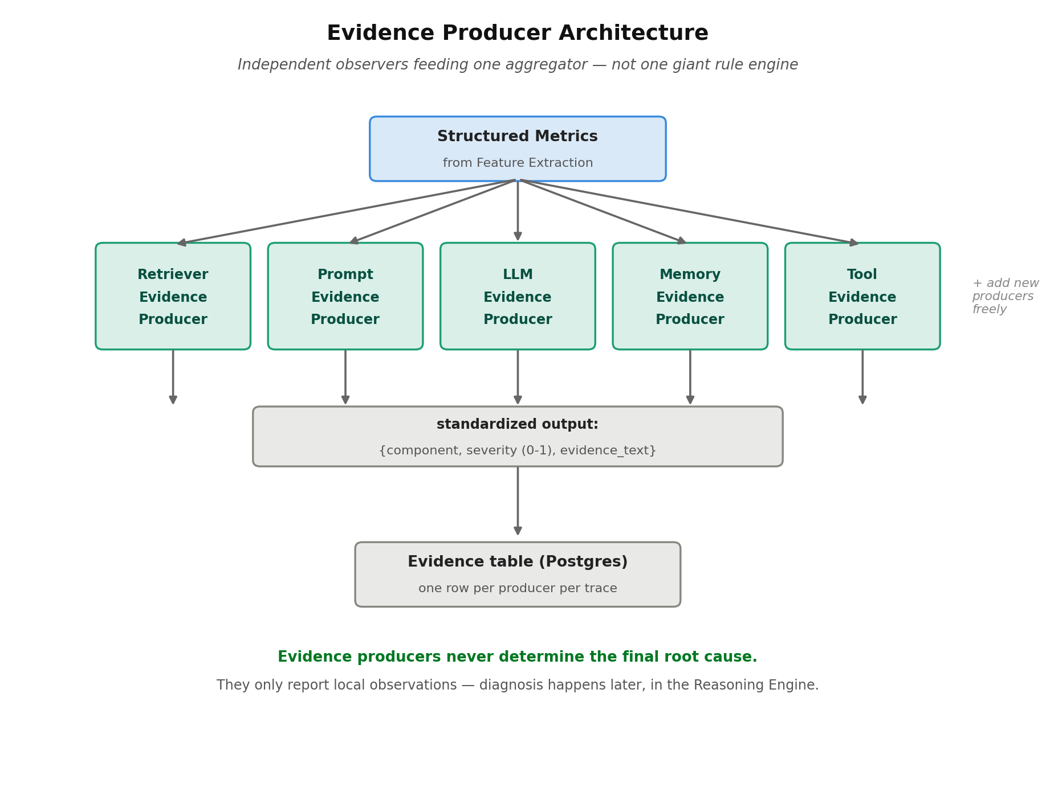
Two properties make this pattern worth its complexity. First, modularity: a new producer (say, for a newly added tool-calling subsystem) is a pure addition — you write one new file, you do not touch any existing producer. Second, and more importantly: evidence producers never get to declare the final root cause. They only report what they personally observed. The actual diagnosis is deferred to a later stage (Section 7.5) that can weigh every producer’s observations together — exactly the way a senior engineer would synthesize multiple signals rather than trust the first alarming number they see.

7.4 Historical Incident Learning Engine
Most observability tools treat every execution as independent, with no memory of the past. This platform instead builds an organizational memory: every diagnosed incident — its root cause, the fix that was applied, whether that fix actually worked, and a vector embedding summarizing the incident — is stored permanently.
When a new trace is being diagnosed, the system embeds a summary of its evidence and searches for similar past incidents using vector similarity (via pgvector, see Section 10). If a sufficiently similar past incident is found, its previously successful fix becomes a strong signal fed into the Reasoning Engine — the system effectively says “this looks like incident #312, and increasing Top-K with hybrid search fixed that one.”
This is conceptually identical to Retrieval-Augmented Generation, except the thing being retrieved is engineering knowledge about past failures, not documents.

7.5 Root Cause Reasoning Engine
This is the single point in the entire pipeline where an LLM is called. It receives exactly three things: the structured evidence list from Section 7.3, the historical matches from Section 7.4, and nothing else — critically, it never sees the raw trace directly.
This constraint is intentional and important. An LLM reasoning over raw, messy execution data is unreliable and expensive. An LLM reasoning over a short, pre-digested, structured evidence list — doing a narrow, well-specified task (rank likely causes, write an explanation, suggest fixes) — is far more reliable. The model is explicitly instructed to never invent evidence and to reason only from what it was given.
Its output is structured: most likely root cause, a confidence score, the evidence that supports the diagnosis, possible secondary causes, an engineering explanation in plain language, suggested fixes, and the estimated improvement if those fixes are applied.

7.6 Failure Prioritization & Recommendation Engine
Rather than naming one root cause with false certainty, the system produces ranked failure probabilities (for example: Retriever Failure 94%, Prompt Engineering 31%, Tool Failure 14%) generated from evidence, not intuition. Each recommendation that follows from this ranking includes its reason, expected improvement, a confidence score, explicit trade-offs, and potential side effects — so an engineer can evaluate a suggested fix rather than blindly trust it.

7.7 Replay Engine
The flagship capability. An engineer opens a failed execution, clicks “What If?”, and changes any configuration value — Top-K, chunk size, the embedding model, temperature, the system prompt, and so on. The platform reconstructs the original pipeline and re-executes it with the modified configuration inside an isolated sandbox. Production data and production traces are never touched by a replay.
The replay produces its own trace, its own metrics, and its own evidence — by reusing the exact same Feature Extraction and Evidence Generation code paths used for real traffic (this is precisely the payoff of the clean module boundaries described in Section 6). The platform then compares original versus replay side by side and reuses the Reasoning Engine to explain, in plain language, why the result changed.

8. Synchronous Ingestion, Asynchronous Processing
A trace arriving at the API and a trace being fully diagnosed are two very different speed requirements, and conflating them is a common mistake in systems like this.
Ingestion must be fast and must never fail because a downstream stage is slow or temporarily broken. Diagnosis (feature extraction through reasoning) can reasonably take a few seconds and should run independently of the request that triggered it.

8.1 The Chosen Pattern
- The API layer validates the incoming trace, writes it to PostgreSQL, pushes a job containing the trace ID onto a Redis-backed queue, and returns 202 Accepted — all in well under a second.
- A background worker, running as a second process inside the same deployed container, pulls jobs off the queue and runs Feature Extraction → Evidence Generation → Historical Search → Reasoning → Recommendation, writing each stage’s output to its own table.
- The frontend polls (or checks a ready flag) to know when a trace’s diagnosis is complete.

8.2 Why Not Kafka, and Why This Still Teaches the Real Lesson
A full message broker like Kafka is the standard production choice at real scale, but it is not a lightweight thing to self-host for free, and this project will never see the throughput that justifies it. Instead, Redis (via Upstash’s free tier) backs a much simpler queue. The interface — “enqueue a job, a worker picks it up later” — is identical to what Kafka or SQS would provide; only the implementation underneath is lighter. This means the pattern you learn (decoupling ingestion from processing, idempotent and retryable background jobs) is the real production pattern, sized appropriately rather than faked.

9. Deployment Topology
The project is hosted as a real website, not run locally, while remaining entirely free. Hosting is split across providers by workload shape rather than forced onto a single platform, because the backend needs a long-running process (for the background worker) that a purely serverless platform like Vercel cannot provide on its free tier.
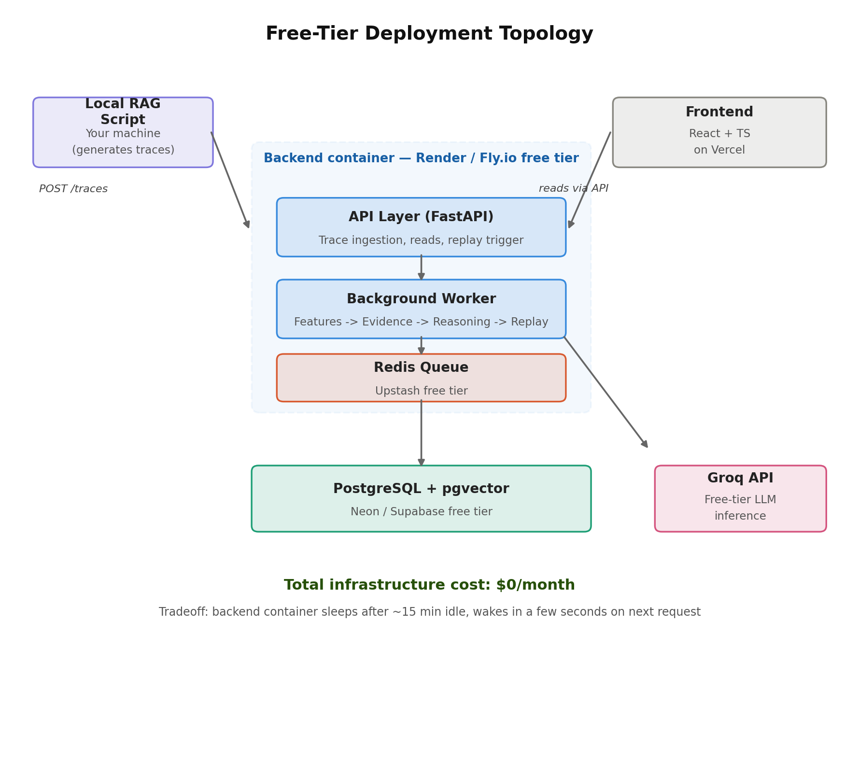
Layer | Choice | Free tier note
Frontend | React + TypeScript on Vercel | Generous free tier, ideal fit for static/SSR hosting
Backend (API + worker) | FastAPI on Render or Fly.io | Sleeps after ~15 min idle; wakes in a few seconds
Database | PostgreSQL + pgvector via Neon or Supabase | Several GB free — far more than this project needs
Queue | Redis via Upstash | Thousands of free commands/day
LLM inference | Groq (open models, e.g. Llama 3.3) | Free tier with generous per-minute rate limits
Trace-generating app | Local Python script on your machine | No hosting needed — it only calls the hosted API
Total infrastructure cost: $0/month. The one honest trade-off is cold starts — if the backend has been idle, the first request after a quiet period takes a few extra seconds while the container wakes up. For a personal project, this is an acceptable and explicitly chosen trade-off, not an oversight.

10. Data Architecture

10.1 PostgreSQL + pgvector Instead of a Separate Vector Database
The original specification calls for Qdrant as a dedicated vector database alongside PostgreSQL. Qdrant is a genuinely strong choice and remains the right call at real production scale, where tuned approximate-nearest-neighbor indexes and advanced payload filtering matter. At this project’s scale — a personal system handling at most tens of thousands of vectors — those advantages are not yet relevant.
Instead, embeddings are stored directly inside PostgreSQL using the pgvector extension. This removes an entire database from the infrastructure (one less service to run, connect to, and keep in sync) at no meaningful cost in capability for this project’s scale. The code is still written against a VectorStore interface, so swapping in real Qdrant later — if the project ever outgrew pgvector — is a configuration change, not a rewrite.

10.2 Schema Design
The V1 schema is intentionally about half the table count of the full specification. Tables that exist in the original spec but add no value until V2 (separate ReplayConfigurations, KnowledgeBaseVersions, a standalone IncidentEmbeddingsMetadata table) are folded into related tables or deferred entirely. The full multi-tenant Organizations / Projects hierarchy collapses to a single org_id column that exists on every table and is enforced in every query — present in the schema for correctness, even though only one organization exists in practice today.
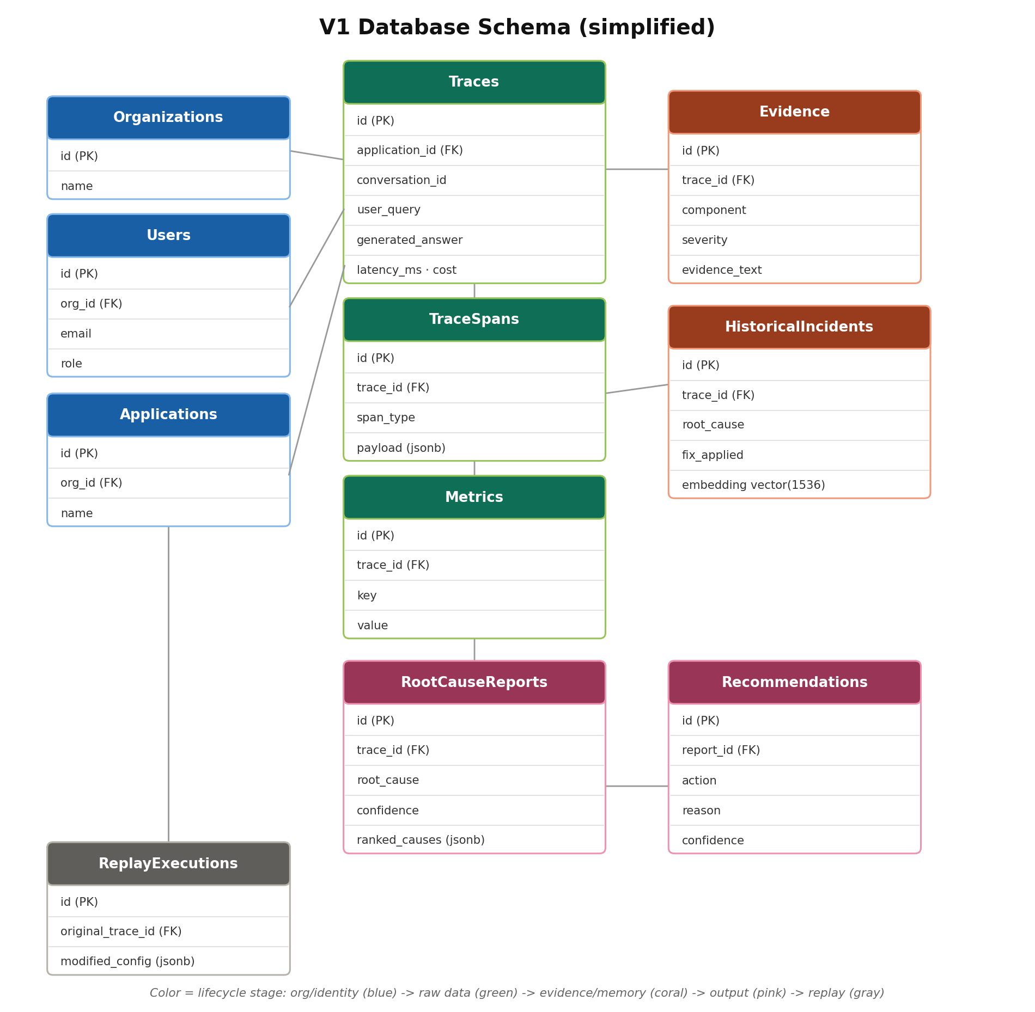

10.3 Why Schema-Level Multi-Tenancy Even for One User
Adding org_id to every table now, and filtering every query by it from day one, costs almost nothing today and avoids a painful migration later. This is a real production lesson, not ceremony: retrofitting multi-tenancy onto a schema that was never designed for it is one of the more painful migrations a growing engineering team can face.

11. API Design
The API surface mirrors the pipeline stages directly — each major capability in the architecture has a corresponding endpoint, keeping the system’s public contract easy to reason about.
Method | Endpoint | Purpose
POST | /api/v1/traces | Upload an execution trace
GET | /api/v1/traces/{id} | Retrieve a trace, its spans, and its diagnosis status
POST | /api/v1/evidence/generate | Trigger evidence generation for a trace (internal/manual use)
POST | /api/v1/reasoning/analyze | Generate a root cause report for a trace
POST | /api/v1/replay | Replay an execution with modified configuration
GET | /api/v1/incidents/similar | Retrieve historically similar incidents
POST | /api/v1/recommendations | Generate engineering recommendations
GET | /api/v1/dashboard | Aggregate analytics for the dashboard

12. Vendor Independence: LLM & Provider Abstraction
The specification’s “Vendor Independent” principle (Section 4) is implemented through a small set of interfaces in the core/ module that every other module depends on, rather than depending on any specific vendor SDK directly.
- LLMProvider — a single interface implemented by a GroqProvider (the default, free-tier choice) and, if ever needed, an AnthropicProvider or OpenAIProvider. The Reasoning Engine calls this interface and never imports a vendor SDK directly.
- VectorStore — implemented by PgVectorStore today; a QdrantStore could be added later behind the same interface without touching any calling code.
This is also the direct answer to a cost constraint that would otherwise be unsolvable: the project cannot pay for LLM calls, so the default LLMProvider implementation points at Groq’s free tier rather than a paid API. Because the Reasoning Engine only ever talks to the interface, this is a configuration decision, not an architectural one.

13. Security
Full enterprise security — JWT, role-based access control, organization isolation, audit logs — is mostly ceremony for a single-user personal project. Implementing it anyway, in a scaled-down but real form, is still worthwhile: it is cheap to do correctly now and expensive to retrofit later.
- JWT authentication is implemented for real — it is needed the moment this is deployed publicly, and is a valuable thing to build once from scratch rather than skip.
- Organization and Project isolation exist as schema-level concepts (Section 10.3) enforced in every query, even though only one organization exists today.
- Replay sandboxing is a hard rule: no replay execution is ever permitted to write to a production trace table. Replays only ever write to ReplayExecutions and ReplayComparisons.

14. Performance & Scalability Posture
The platform is built to be lightweight by minimizing LLM usage — the LLM is only ever called after feature extraction, evidence generation, and historical search have already narrowed the problem down. This keeps the system’s default behavior cheap, fast, and deterministic.
At the scale this project actually operates at (one person, at most thousands of traces), horizontal scaling, heavy caching layers, and streaming infrastructure are not required. The patterns that matter — background workers, asynchronous processing, and pagination on list endpoints — are still implemented for real, because they are inexpensive to build correctly from the start and are the actual mechanism that would let the system scale further if it ever needed to.

15. Summary of Key Tradeoffs
Every major deviation from the original enterprise-scale specification is a deliberate, explainable choice — not a corner cut by accident. This table is the single place to look to see, at a glance, what changed and why.
Decision point | Spec called for | V1 choice | Why
Service architecture | 6 independent microservices | Modular monolith, one deployable | No team/scale need yet; avoids 6x ops overhead; same clean seams for later split
Vector storage | Dedicated Qdrant cluster | PostgreSQL + pgvector | One fewer service to run; plenty for this scale; swappable via interface
Processing model | Event queue (implied Kafka-class) | Redis-backed lightweight queue | Same decoupling pattern, free-tier feasible
LLM provider | OpenAI/Anthropic-class APIs | Groq free tier behind LLMProvider interface | Zero cost constraint; interface keeps it swappable
Multi-tenancy | Full Org/Project hierarchy + RBAC | Schema-ready (org_id everywhere), single real org | Avoids painful future migration without ceremony now
Evidence Graph (causal graph) | Module 7, full causal traversal | Deferred to V2 | Needs real evidence data first; V1 ships flat evidence list
Automated replay experiments | Multi-config search & ranking | Deferred to V2 | Single-config manual replay must work first

16. Frontend
The frontend is a React + TypeScript application that becomes the human-facing layer over everything described above. It is deliberately built last (Section 17, Phase 7), once the backend pipeline is already producing real, correct data — building UI against logic that does not exist yet is a common source of wasted rework.

16.1 Trace Explorer
Displays the execution timeline, spans, latency, the assembled prompt, retrieved documents, the generated answer, the evidence produced for this trace, and the resulting root cause report, with a button to trigger a replay.

16.2 Replay Page
A split-screen view: the original execution on the left, the replay on the right. Retrieved documents, prompt, and every key metric (latency, cost, groundedness, faithfulness, similarity, citations) are compared side by side, alongside the plain-language explanation of why the result changed.

16.3 Dashboard / Analytics
A minimal V1 analytics view: a handful of aggregate numbers (most common failure categories, average latency and cost, replay success rate). The full trend-detection and knowledge-gap analytics described in the original specification are deferred to V2, once there is enough historical data for trends to be meaningful.

17. 30-Day Build Plan
The plan below is scoped to roughly two hours of focused work per day, for thirty days. Each phase is sized to end with something runnable — not just code written — because visible progress every few days is what keeps a solo, after-hours project alive. Day numbers are a guide, not a contract: if a day runs long or short, the plan flexes around where the work actually got to, rather than mechanically advancing regardless.
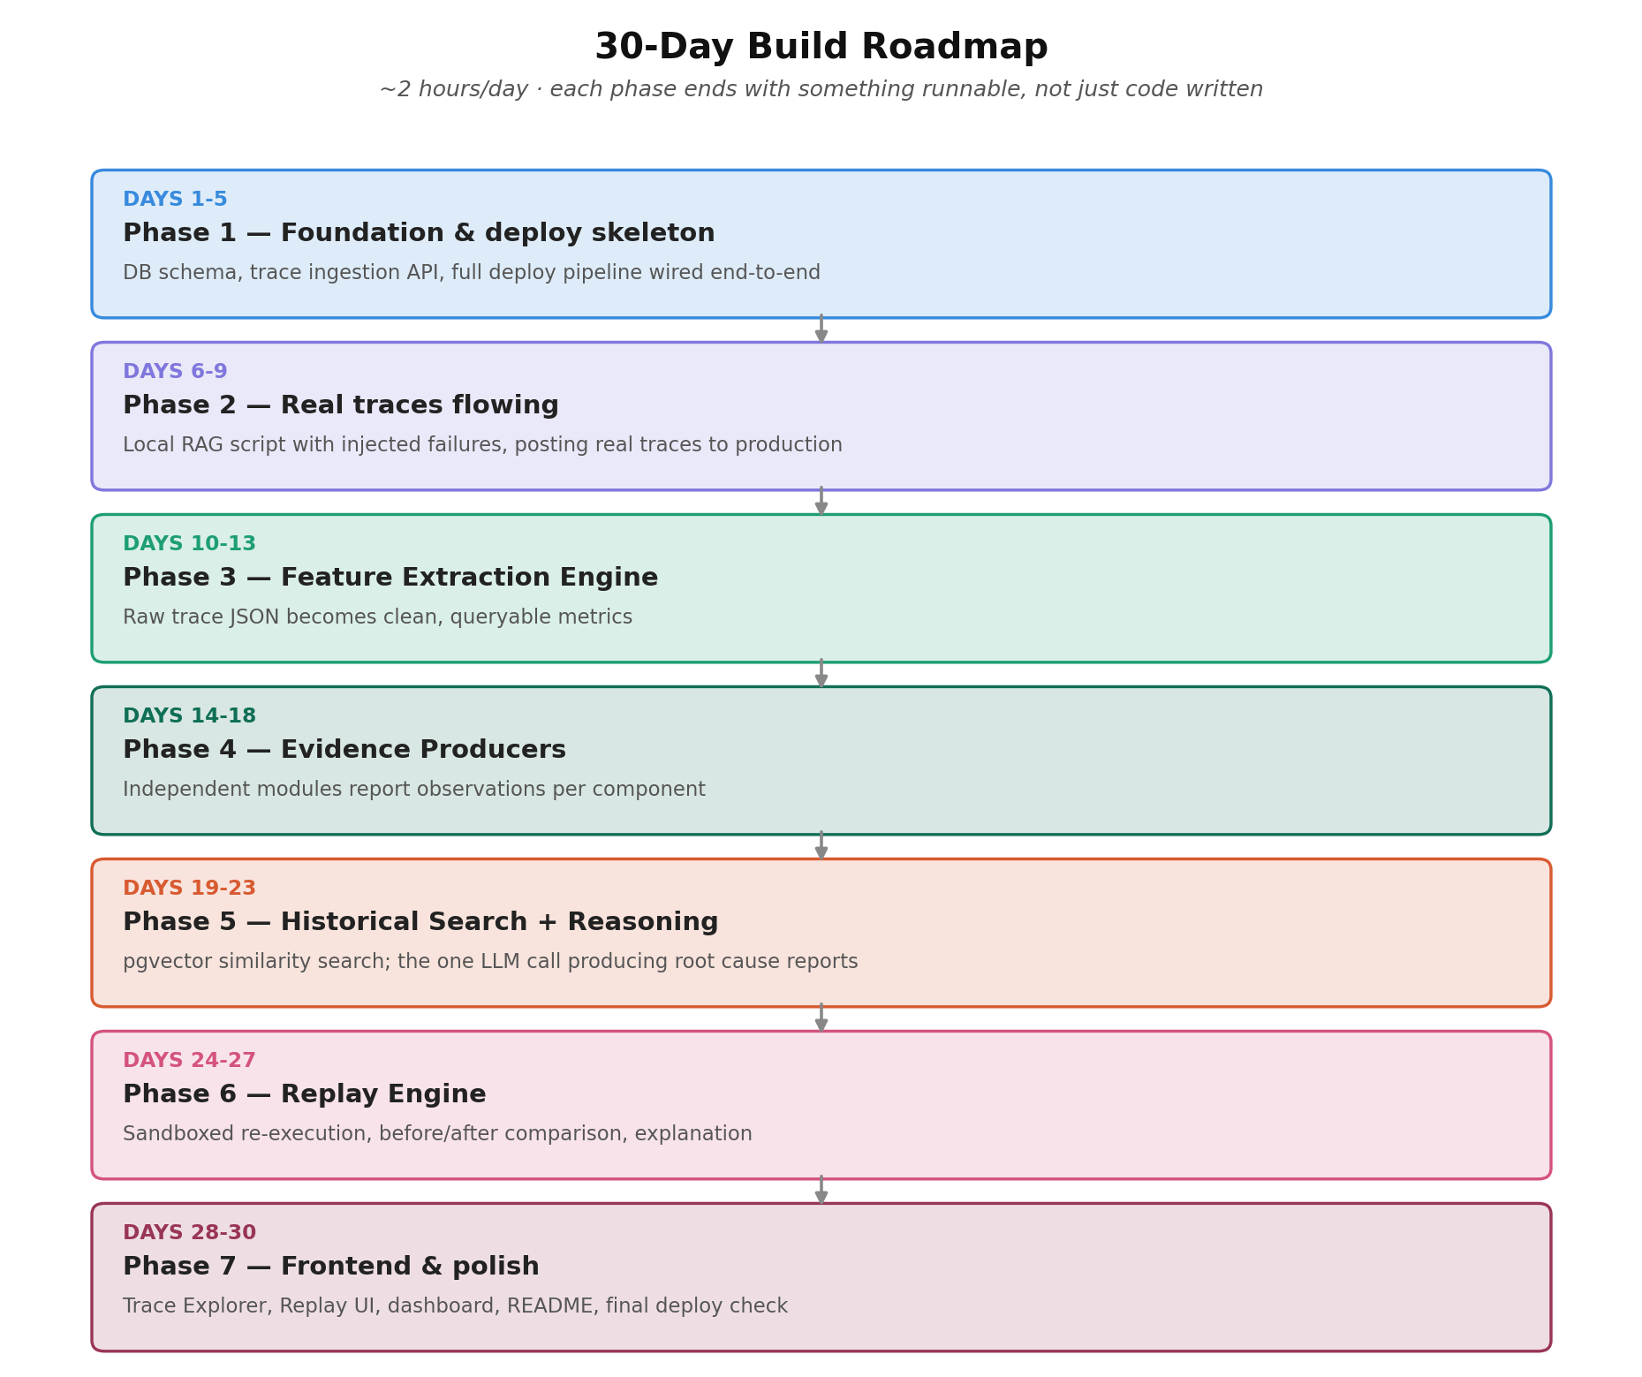

17.1 Phase 1 — Foundation & Deploy Skeleton (Days 1–5)
The goal of this phase is deliberately boring: get an empty system fully wired and deployed before any real logic exists. Every later day becomes “add a feature,” never “fight infrastructure.”
Day | Focus | Learning objective
1 | Repo structure (modular monolith folders), Python env, FastAPI hello-world, Postgres connection | Why structure by domain (trace/, evidence/) instead of by technical layer
2 | SQLAlchemy models for Organizations, Users, Applications, Traces, TraceSpans; first Alembic migration | Migrations as the source of truth for schema
3 | Build POST /api/v1/traces and GET /api/v1/traces/{id} for real; validate with curl/Postman | What makes an API payload schema good for a system that must evolve
4 | Set up Redis (Upstash) and a minimal background worker that just logs receipt of a job | Decoupling ingestion from processing; producer/consumer pattern
5 | Deploy backend to Render/Fly, push a skeleton React app to Vercel calling a stubbed dashboard endpoint | The deployment topology; why frontend and backend deploy independently

17.2 Phase 2 — Real Traces Flowing (Days 6–9)
A small RAG application is built as the test subject, with deliberate, known failures injected so the platform’s diagnoses can later be checked against ground truth.
Day | Focus | Learning objective
6 | Local RAG script: load sample company-policy documents, chunk, embed, store in pgvector | What chunking and embedding actually do mechanically
7 | Wire retrieval + prompt + Groq LLM call into the script; package and POST a full trace | This is the AI Application Layer — why it must stay decoupled from the platform
8 | Build 2–3 deliberately broken scenarios (bad metadata filter, low Top-K, chunk splits a key sentence) | Failure injection as a testing discipline
9 | Run repeatedly, confirm traces and spans land correctly in the hosted DB via direct SQL | Buffer / catch-up day

17.3 Phase 3 — Feature Extraction Engine (Days 10–13)
Raw, nested trace JSON becomes flat, queryable numbers — the translation layer every later stage depends on.
Day | Focus | Learning objective
10 | Metrics table usage pattern; extractor for retrieval metrics (avg/max/min similarity, chunk count) | Turning nested data into flat, comparable numbers
11 | Prompt/context metrics: prompt length, context tokens, completion tokens | Token counting and why it matters for cost and context-fit
12 | Latency/cost metrics; wire extraction into the worker automatically after ingestion | Pipeline composition — one worker, multiple stages, clear handoff
13 | Test against Day 8’s broken-scenario traces; confirm the numbers look wrong where expected | Buffer / catch-up day

17.4 Phase 4 — Evidence Producers (Days 14–18)
The heart of the “no hardcoded rule pile” philosophy (Section 7.3), built one independently testable producer at a time.
Day | Focus | Learning objective
14 | Define the Evidence table and the producer interface; build the Retriever Evidence Producer first | Designing a plugin-style interface so each new producer is a small addition
15 | Prompt Evidence Producer (length anomalies, missing expected context) | Setting sane statistical baselines without scattering magic numbers
16 | LLM Evidence Producer — deterministic groundedness/citation-coverage heuristic | Building a deterministic faithfulness check, not another LLM call
17 | Wire all producers into the worker pipeline; confirm evidence rows for each broken trace | Validating the plugin pattern end-to-end
18 | Buffer/catch-up; optionally add a fourth producer (Memory or Tool) as a stub | Establishing the extension pattern without over-investing

17.5 Phase 5 — Historical Search & Reasoning (Days 19–23)
The two AI-adjacent stages: similarity-based memory, and the single LLM call that produces an actual diagnosis.
Day | Focus | Learning objective
19 | HistoricalIncidents table with pgvector column; embedding step for evidence + root cause summaries | What makes a good incident summary for embedding
20 | Implement pgvector similarity search; manually seed 2–3 historical incidents | The cold-start problem in recommendation-style systems
21 | Build the LLMProvider interface + Groq implementation; write the Reasoning prompt template | Structured-output prompting; why this is the one LLM call in the pipeline
22 | Wire Reasoning into the worker; store results; test against broken-scenario traces | Checking that the LLM’s diagnosis actually matches the evidence
23 | Buffer/catch-up; tighten the prompt template based on Day 22 results | Iterating on a prompt against real evaluation cases

17.6 Phase 6 — Replay Engine (Days 24–27)
The flagship feature, only buildable now because it reuses every module built in Phases 2–5.
Day | Focus | Learning objective
24 | ReplayExecutions table; design the replay endpoint contract (trace ID + config overrides in) | Why replay must never write to production trace tables
25 | Implement replay execution, reusing the existing retrieval/prompt/feature/evidence code paths | The payoff of clean module boundaries from Section 6
26 | Build ReplayComparisons (diff original vs replay); reuse Reasoning for the explanation | Reuse over rebuilding — a sign of correct earlier boundaries
27 | Test a full replay loop on the known broken-retrieval scenario end to end | Validating the flagship feature against ground truth

17.7 Phase 7 — Frontend & Polish (Days 28–30)
Turning everything validated so far via API calls and SQL into something a human can actually look at and trust.
Day | Focus | Learning objective
28 | Build the real Trace Explorer page (timeline, evidence, root cause report) | Where most of the “is this readable to someone else” work happens
29 | Build the Replay split-screen page and a minimal Dashboard/Analytics view | Translating backend comparisons into a clear visual diff
30 | Final pass: fresh cold-deploy test, honest README (V1 vs deferred to V2), full self-demo | Closing the loop — confirming the whole system as a coherent product

18. Deferred to V2
These capabilities are explicitly part of the original vision and are good ideas — they are deferred, not rejected, because building them before V1’s pipeline produces real evidence data would mean designing against a problem that does not exist yet.
- Evidence Graph — representing a trace as a causal graph of components with traversal to find the most probable failure chain, rather than a flat evidence list.
- Automated Replay Experiments — exploring multiple configurations automatically, ranking them, and recommending the best-performing one (effectively an optimization engine).
- Learning From Replay — treating successful replay experiments as additional historical knowledge that biases future recommendations.
- Full trend analytics — hallucination trends, knowledge-base freshness tracking, prompt drift and embedding drift detection.
- Integrations — CI/CD, GitHub, Jira, and Slack notifications.

19. Glossary
Term | Meaning in this project
Trace | A complete structured record of one AI application execution — query, retrieval, prompt, answer, and metadata.
Span | A sub-step within a trace (e.g. one retrieval call, one tool call), stored separately for fine-grained timeline display.
Evidence producer | An independent module that inspects one subsystem’s metrics and reports a severity + observation, without claiming a root cause.
Root cause report | The structured output of the single LLM call — diagnosis, confidence, supporting evidence, and recommendations.
Replay | A sandboxed re-execution of a past trace with modified configuration, compared against the original.
Modular monolith | A single deployable application internally organized into independent modules with enforced one-directional boundaries.
pgvector | A PostgreSQL extension enabling vector similarity search directly inside the same database used for relational data.

20. Closing Notes
Every simplification in this document is logged in Section 15 specifically so that the difference between “what a fully-resourced enterprise team would build” and “what this V1 actually builds” is never accidentally lost. That table is the honest core of this whole project: it is not a smaller version of the idea, it is the same idea, correctly scoped to one person, thirty days, and zero dollars — with every seam left in place for the parts that were deliberately deferred.
The measure of success for this project is not whether it resembles a polished SaaS product. It is whether, at the end of thirty days, you can explain — from first principles, in an interview or to yourself — why every one of these architectural decisions was made, and what you would do differently at real production scale.

